Versioning and Lifecycle Policies

Lifecycle Policies:

STEPS:

1.Log into your AWS Console and select ‘S3’ and Navigate to your Bucket where you want to implement the Lifecycle PolicyClick on ‘Properties’ and then ‘Lifecycle’

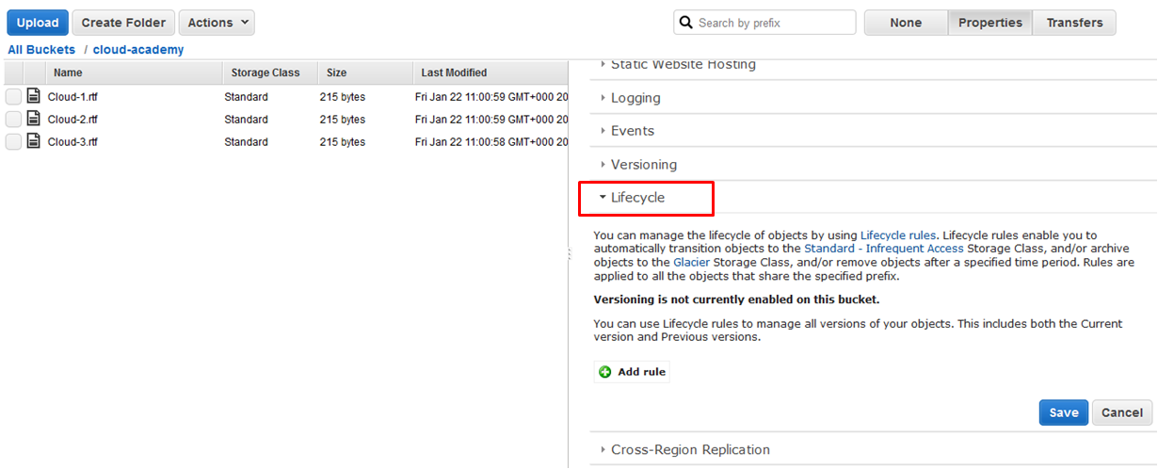

2.Click ‘Add rule’

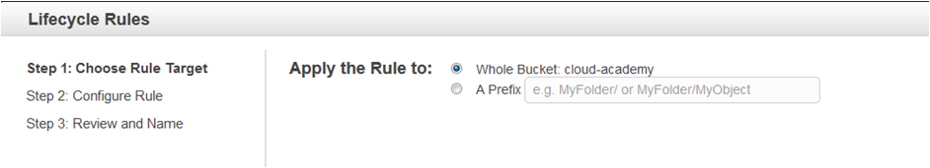

3. Select ‘Whole Bucket’ and click ‘Configure Rule’.

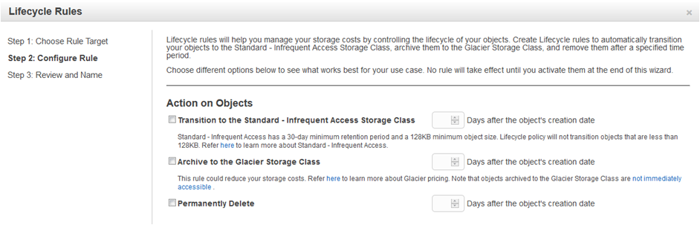

4.Select ‘Permanently Delete’. So that this data is removed after 2 weeks from the objects creation date, so enter ‘14’ days and select ‘Review’.

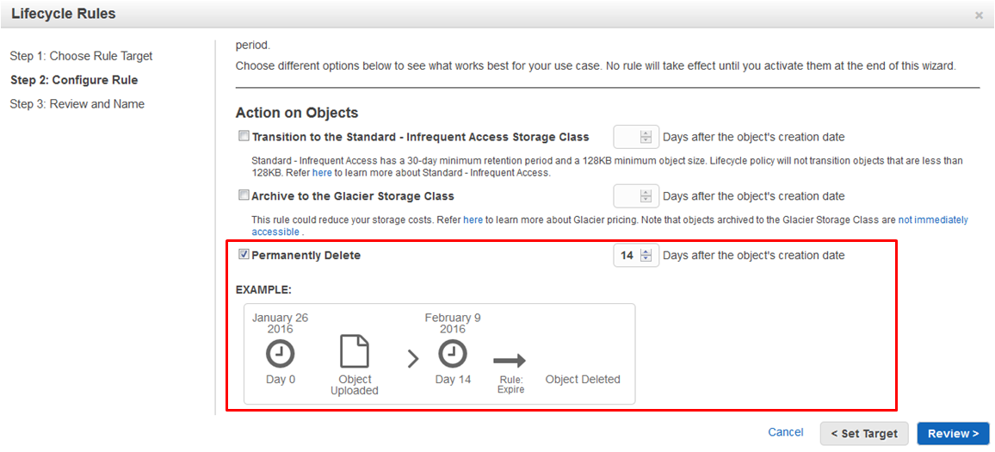

5. Give the rule a name and review your summary. If satisfied, click ‘Create and Activate Rule’

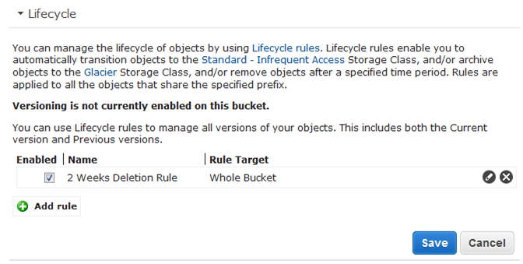

Versioning

1. Log into your AWS Console and select ‘S3’ and Navigate to your Bucket where you want to implement Versioning thenClick on ‘Properties’ and then ‘Versioning’

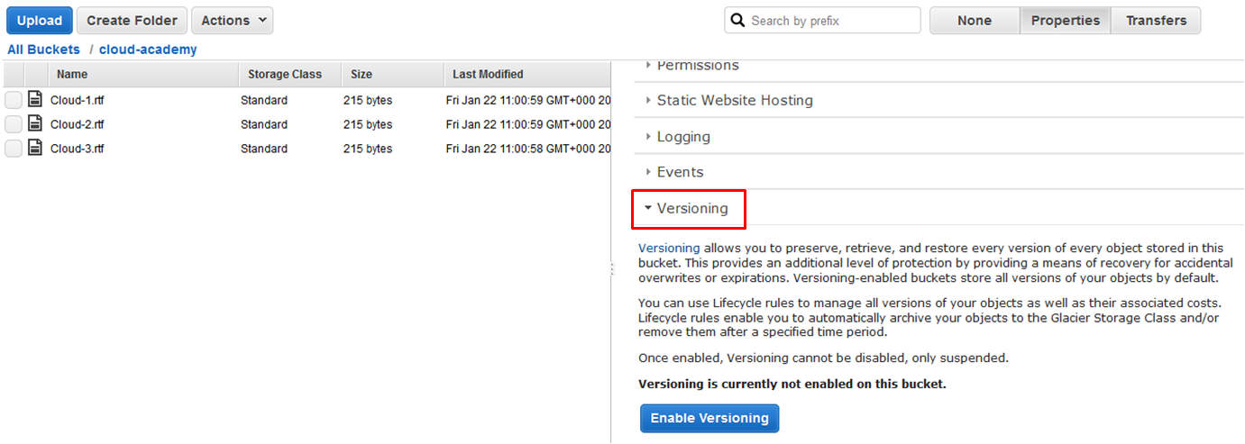

2. Click ‘Enable Versioning’,Click ‘OK’ to the confirmation message .Versioning is now enabled on your Bucket.

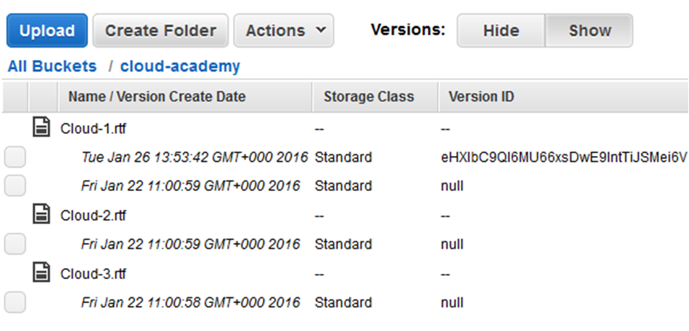

3.To see different versions of an object within your bucket follow the steps below:

From within the Bucket, you will notice you now have 2 new buttons at the top of the screen under ‘Versions: Hide & Show’

Article 9 - 7

4. Simply click on ‘**Show**’ to view the different versions of all your objects within the Bucket. As you can see from below, a different Version has been created following my update to the file displaying the date and time of the update.